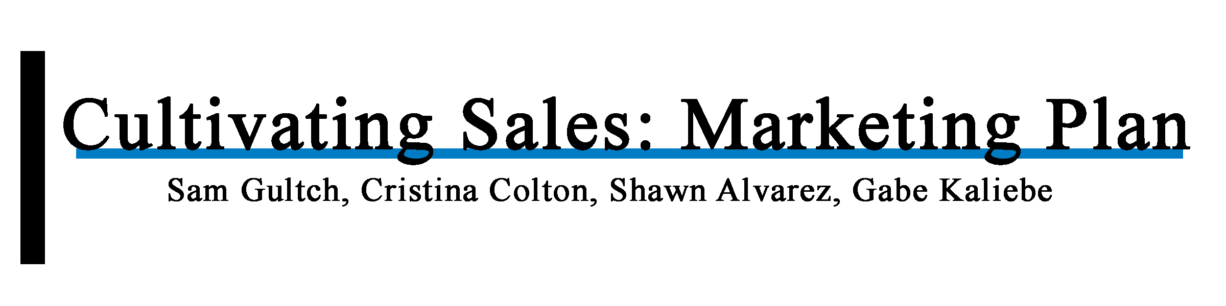

Contact

Sam Gultch, ID#: 991175146, E-mail: sjgultch@uwm.edu

Cristina Colton, ID#: 991222100, E-mail: [coltonca@uwm.edu](mailto:coltonca@uwm.edu)

Shawn Alvarez, ID#: 991264929, E-mail: alvare54@uwm.edu

Gabe Kaliebe, ID#: 991303808, Email: gkaliebe@uwm.edu

**II. Executive Summary**

Cultivating Sales is a unique program that you can buy. It is a CRM system that caters to the business-to-business atmosphere. This marketing plan will help the owner of Cultivating Sales, Melissa Blair, optimize on her sales and brand awareness. The goal of the plan will be to provide the actions to grow Cultivating Sales.

Cultivating Sales is a new company that offers a service of a more modern engagement platform that makes serving customers easier, faster, and more profitable. The goal is to get companies to eliminate the traditional and outdated contact page and replace it with a client service portal and instant call-to-action buttons that saves time for the company and their clients.

To find the best possible marketing opportunities, we researched the industry in comparison to Cultivating Sales. We began by looking at the unique things that Cultivating Sales offers. We included many of the basic information that was given to us in the beginning of our research. This can be found in the "Current Marketing Situation" section. After that we researched the industry. We used this to come up with a SWOT Analysis. A SWOT Analysis shows potential strengths, weaknesses, opportunities, and threats that Cultivating Sales should be aware of.

The current biggest key issue is the low customer base. This is understandable as a new business; however, it is important to have a plan to increase the customer base. We have suggestions to fix these "Key Issues" located in the "Marketing Strategy" section of the paper. These strategies include: Social Media Calendars, Podcasts, SEO, Videos, PPC Advertising, Display Ads, Fixing Website, Email Newsletters, Hiring an Employee, and Free Trial to Premium Plan retention strategies.

**III. Table of Contents**

* 1. Title Page.......................................................................................... 1
  2. Executive Summary.......................................................................... 2
  3. Table of Contents.............................................................................. 3
  4. Current Marketing Situation............................................................. 4
  5. SWOT Analysis................................................................................ 13
  6. Key Issues......................................................................................... 15

VII. Objectives........................................................................................ 16

VIII. Marketing Strategy......................................................................... 17

IX. Tactics/Actions Programs.................................................................. 21

X. Controls............................................................................................... 23

XI. Resource & Budget Requirements/Conclusion................................. 24

XII. Appendix.......................................................................................... 27

**IV. Current Marketing Situation**

* Background information on the market: According to CRM Market Share Report 2015, revenue growth is based on the services provided within the application. The top competition in the market is Salesforce, SAP, Oracle, Microsoft, and Adobe. From the years 2014-2015 there was a 12.3% growth in CRM software with the market totaling $26.3 Billion.
  + Products: Free Plan including (restrictions apply): CRM, Inbox, Client Cards, Client History, Schedule Management, Auto Confirmation Emails & Texts, Email Marketing Campaign, Calendar Syncing, Payment Tracking, Mobile Customer Portal, Website Buttons, and Lead Generation Widgets. $79/ per month (Includes benefits of Free Plan also): Staff Access to 2 Employees, Administration view of Staff Calendars, Assign Staff Appointments, Promote Business via Text Campaigns, Tract Deliveries, Text Reminders, Google Analytics, 3rd Party Integrations via Zapier, Create Discount Coupons, Custom Client Tags for Segmentation, Mark Clients for Follow Ups, Edit Email Notifications, and 20 GB of Online Storage. $129/ per month (includes all previous services): 5 Staff Accounts, Set Staff Roles, Route Customer Requests to Staff, Staff templates for Editing Campaigns, Custom Notifications per Service, Customize Text Message Campaigns, Choose Domain for Customer Portal, and Brand CRM with Logo & Company Colors.
    - Services: The goal is to get companies to eliminate the traditional and outdated contact page and replace it with a client service portal and instant call-to-action buttons that saves time for the company and their clients.
      * Macro Environment: Governments use CRM on the federal, state, and municipal level to strengthen the relationship between citizens and the part of the economy that is controlled by the government. Examples of this can be protecting companies from each other and protecting consumers from unfair business practices. CRM are meant to optimize revenue and customer satisfaction through technology or personal connections.

Current

* + Environment: There are two approaches businesses can use to manage their interactions with potential customers and current clients. Using software to create functional analytics to improve sales and customer satisfaction might become more popular in the future. There is also a human-to-human aspect where a companies employee delivers value to customers as well as problem solves when conflict arises.
    - Competition: Infusionsoft, Marketo, Salesforce, and Dubsato are CRM software that can be considered immediate competition. Larger companies such as Adobe, SAP, Oracle, and Microsoft are also in the market however, they do business with larger businesses than solopreneurs.
      * Abilities to fit into external market: Since the business can be purchased anywhere in the world as long as it is accessed on the website, it can go international at any moment. Video conferencing with potential business partners around the world may be an avenue to explore.

Past

* + Marketing activities: Cold calling, free memberships, networking, and word-of-mouth marketing.
    - Define the range of products offered: CRM, Inbox, Client Cards, Client History, Schedule Management, Auto Confirmation Emails & Texts, Email Marketing Campaign, Calendar Syncing, Payment Tracking, Mobile Customer Portal, Website Buttons, and Lead Generation Widgets. Staff Access to 2 Employees, Administration view of Staff Calendars, Assign Staff Appointments, Promote Business via Text Campaigns, Tract Deliveries, Text Reminders, Google Analytics, 3rd Party Integrations via Zapier, Create Discount Coupons, Custom Client Tags for Segmentation, Mark Clients for Follow Ups, Edit Email Notifications, and 20 GB of Online Storage. 5 Staff Accounts, Set Staff Roles, Route Customer Requests to Staff, Staff templates for Editing Campaigns, Custom Notifications per Service, Customize Text Message Campaigns, Choose Domain for Customer Portal, and Brand CRM with Logo & Company Colors.
      * Changes in customer base: Since the introduction to the business, the customer base has grown from 2 to 7 paying customers. The goal in the future is to obtain 200 paying customers.

**Market:**

* The majority of software tools are built for the small, medium and large companies
* Most software tools are not made for the micro-companies - Cultivating Sales wants to fill that role
* This system incorporates tools that other companies are having to purchase 1 by 1
* The only other tools that provide a suite of solutions are Infusionsoft, Hubspot, Marketo and SalesForce - they are very complex, time intensive, and high-priced
* You can find more info on CRM Market Share and CRM Market Revenue in Appendix A.

**Macro Environment:**

* Programmers can have a very positive or negative effect on the business
* So far the software is working perfectly
* If that company were to go under or even disappear, the company would be in big economic trouble (no indication that it is going to happen but it could)
* Have additional tools/services that the company will offer to minimize that risk
* The economy always plays a role in any business - times are good right now and even the smallest business can afford the service
* If expenses had to be cut, clients may choose to drop the service and that would negatively impact sales
  + Some companies might just go out of business altogether if the economy goes south

**Internal Trends:**

* Started selling in February, 2017, and currently have 7 paying customers
* Need to average 18 new customers a month to get to the goal of 200 by the end of the year
* Expect the average sale to be the $79.00/month plan - not factoring in onboarding fees or commissions being paid
* Overall expenses are very low as overhead is minimal
* Below is a simple idea of the numbers

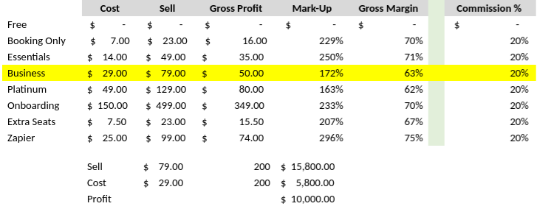

Fig 1. Cost, sales, gross profit, mark up, gross margin, and commission with the services provided.

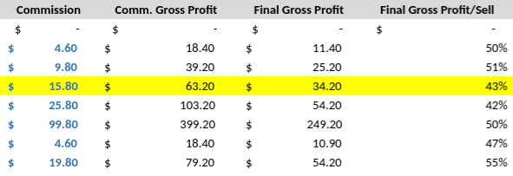

Fig 2.

**Product/Service:**

* A new way to manage your business and engage with clients online
* Integrates with all of the most popular online tools (Google, Facebook, PayPal, etc.)

**Inbox:**

* Very simple and intuitive, similar to a standard email
* All communication with all clients in one place for whenever they contact, pay, or schedule an appointment
* Can add new clients for scheduling and share documents
* Can send an invite to the client through email to visit the LiveSite client portal
* Easy responding to client requests
* Can set a reminder to follow up with a client with a specific date and note to specify - when the time comes you will be notified by email

**Contact Info:**

* Quick overview of each client with their personalized client card
* Includes any info about the client that you would like to document
* Booking information about previous meetings
* Lists all paid and open payments for the client
* Lists all documents you have shared with the client
* Lists all the conversations and interactions you have had with the client

**Calendar:**

* Easily and effectively manage your meetings with your clients
* All meetings and appointments need to be scheduled on this calendar so that the client can be notified and reminded about the appointment
* Schedule new appointments with existing and new clients
* View and manage existing appointments
* Can send invoices or record payments

**Payments:**

* Lists all the open/past due/completed payments and invoices for your clients
* View and manage payments including issue a new invoice
* Send a payment request or record a payment that was made offline

**Documents:**

* Lists all documents shared with clients
* Easily share and request documents with clients

**Campaigns:**

* Tool to promote your offered services and drive more business/revenue from clients
* Use campaigns to target existing clients or new prospects, invite them to book an appointment, register for a class, make a payment, etc.
* Ultimate goal is to get clients to interact with your business
* Creating and sending a campaign is simple and quick - create it on-the-go from mobile devices
* Track campaign results in real time, including delivery stats and client actions
* No design skills are necessary - you can easily create and send beautiful, mobile-friendly emails that will engage your clients and increase your revenue

**Strengths of Product:**

* User Friendly
* Modestly priced for the value
* Combines a number of tools into 1 platform
* Real people for support
* In text messaging along with email
* Add Action Buttons to their website.
* Provides a Client Portal.
* Allow customers to drop some of the other monthly subscriptions since they no longer need them.
* Can book one-on-one appointments or group events like classes.
* Customers are showing great conversions in their campaigns - 1 client booked 10 appointments from 1 text campaign.

**Weaknesses of Product:**

* After the first 500 text messages, the customer than has to pay for additional text packages.
* New to the market
* Keeping the high touch support will be challenging as the company grows - will have to hire someone which will cut into profits
* ‘Just enough’ theory - the goal is to keep our platform simple enough and still provide great functionality - some customers are going to want more complexity as they grow and will need to move onto a larger platform like Infusionsoft, etc.

**Competition:**

* Majority of software tools are not built for the micro-company.
* There are CRM’s that do majority of the things offered, but not incorporating all the tools needed to manage a company’s inbox, contact info, calendar, payments, documents, and campaigns
* The tools that provide a suite of solutions are **Infusionsoft**, **Marketo**, and **Salesforce**
* These companies are complex, time intensive, and high priced.
* **Dubsato** could be looked at as an immediate competition, but it seems to not offer all the tools that Cultivating Sales does
* One customer even uses Dubsato in conjunction with Cultivating Sales

**Consumer/customer:**

* Finding the best success with Network Marketing companies:
  + Ruby Ribbon
  + Pampered Chef
  + Norwex
  + Mark Kay
  + Cabi
  + Many More
* A network marketing company has a signature product and they recruit individuals to sell for them for a commission - they are not employees but independent contractors
* The Cultivating Sales System provides them with the tools to help run their business
* Rely heavily on word-of-mouth - already have 3 Ruby Ribbon consultants with a number more who will be contacting us
* The other companies to focus on are ones that have a number of classes they need to book up
* women’s financial wellness center that has a variety of classes for their customers to take dog agility training company that also runs a variety of classes

**Distribution Channels:**

* Cultivating sales is still in its infancy stages and currently uses a direct distribution technique This means that currently it is sold directly from the producer to the consumer or cultivating sales to the users
* This seems to also be the direction the company will be going for the near future
* If/When Cultivating Sales gains many clients then the company can decide if they will want to go another route
* That being said, the current focus of Cultivating Sales is to gain clients by using a direct distribution technique that goes from the producer to the consumer

**Evaluation of previous marketing tactics:**

* Cold-calling
* Allowing the customer to utilize the software for free
* Word-of-mouth

**V. SWOT Analysis**

**Strengths:**

* All-in-One Software tool targeted specifically at the Micro-Company
* Lead conversions, email and text marketing
* Very affordable
* Free trial available
* Easy to use and learn
* Appointment reminders
* Cuts down on time in appointment set-up by having a built in appointment setting process
* Everything is linked together so if someone sends out a marketing campaign, the statistics are built right in

**Weaknesses:**

* Brand new to the market
* Have to build customer base through relationships
* Clarity on what the business does
* No proven marketing technique

**Opportunities:**

* Cultivating sales allows small businesses to keep up with current business trends in the digital world. Unlike similar products, this is built for small businesses. This opens up a completely different market that the competition don’t have.
* New business with little customers allows her room to make small changes easily to attract more customers if needed.
* Get one raving fan in a Network Marketing Company and let them spread the word for us (word-of-mouth marketing)

**Threats:**

* Technology is rapidly changing - it’ll be important to update if/when needed in order to stay ahead of possible competition (Apple banned us from publishing to their app store if we used software to build our mobile apps)
* The headquarters of a Network Marketing Company may find a way to ban them from using my system or develop their own tool in time

**VI. Key Issues**

**Issues Analysis:**

* Brand recognition - New business, with few people knowing it exists.
* Complexity - We believe that most business owners can benefit from this. That being said, it’s important to make a strategy where this can be quickly explained
* Customers - Currently a very minimal amount of customers. With the low pricing, cultivating sales will need at least dozens of customers to be profitable.
* Marketing - No proven marketing strategy.
* Company policy - “The headquarters of a Network Marketing Company may find a way to ban them from using my system or develop their own tool in time”
* Rapidly changing industry - technology is quickly changing, possible updates needed to keep up with competition every so often

**Key Issues:**

* Money - temporary issue at the moment
* Following up on prospects - working on about 30 potential clients right now
* Need more exposure for personal testimonies (Google, Facebook, LinkedIn, etc.)
* No staff - potentially hire staff when reached a certain number of subscribers (sales person is an immediate possibility, salary position not likely any time soon)
* Time – Limited amount of time, and many possible task
* Fix the website - a lot of uncertainty with the website content and design
* Figure out the mission statement - clearer and more direct
* Currently ignoring Facebook and other social media
* Clients - Need to find more clients
  1. **Objectives**
* **Goal:** Gain awareness of brand
  + **Objective:** create a social media plan and calendar
  + **Objective:** Continue networking at “X” number of local events with “X” number of locals per month
* **Goal:** Increase profit
  + **Objective:** Reduce time spent on tasks where you can get others to do that work ie. website help, video help, content help. Get more clientele.
  + **Objective**: Make a goal to gain “X” number of clients per month.
  + **Objective:** Update to a smooth looking website in order to show customers that cultivating sales has extensive knowledge with digital technology.
* **Goal:** Gain advantage over competitors
  + **Objective:** Develop a strategy where you are standing out amongst competitors
  + **Objective:** Continue offering great customer service, while build personal relationships
* **Goal:** Hire Staff
  + **Objective:** Find a certain $ goal amount that can maintain at least one employee who can help maintain social media and customer service help
  + **Objective:** Design a plan on specific tasks you would like staff to do. (Ex: Should they cold call? Email? Research the market?)
  + **Objective**: Find your R.O.I. on staff to help design salary, incentive, etc
* **Goal:** Keep clients
  + **Objective:** Maintaining current clientele interest by engaging in an email newsletter plan
  + **Objective**: Continue building relationships with local customers with your great customer service skills
* **Goal:** Fix Website
  + **Objective:** Hire outside help to fix website
  + **Objective:** Determine uses for website, your budget, and why it will benefit you.

# 

# VIII. Marketing Strategy

* **Social Media Calendar** 
  + Utilizing Hootsuite (Hootsuite is one of many tools referred to as a “Social Media Management System” or tool. It helps you keep track and manage your many social network channels. It can enable you to monitor what people are saying about your brand and help you respond instantly.), or programs like this to help you
* **Blog**
  + According to [Hubspot](https://www.hubspot.com/marketing-statistics), businesses which blog 16 or more times a month get on average 3.5 times more website traffic than those which don’t (HubSpot)
  + Blogging with useful content improves site's SEO

·  **Podcasts**

* + Put into social media calendar (good for B2B businesses in content marketing)

· **SEO**

* + Search engine optimization in your website
  + Identifying targeted keywords, creating useful content, and building high-quality backlinks to your site
  + Google has free tools to help you collect and analyze data about your website and its performance (trends, analytics, search console, PageSpeed Insights)
  + Blogging

· **Create a new comprehensive video**

* + Utilizing something like Animaker (“Make Infographic Videos for Free.”)
  + A fun strategy to engage your potential customers in learning information about your system that you offer in a different way. Could be used as promotional material in the future.

· **PPC Advertising - Google AdWords**

* + Advertise your company by search ad’s: (See Figure 3)



Fig 3. Search ad example. (“Digital Display Ads.”)

* + Advertise your company by display ad’s: (See Figure 4) (“Digital Display Ads.”)

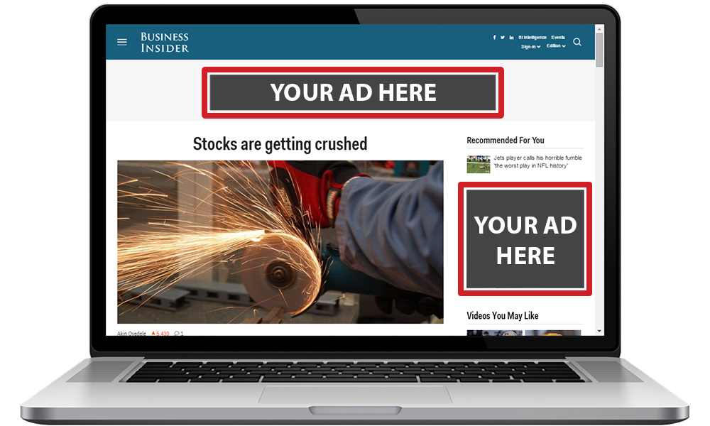

Fig 4. Digital display ad example.

* + You should have a big enough budget to set aside a decent amount for PPC advertising right now
* **Fix Website**
  + Suggestion 1: Put the video below the image.

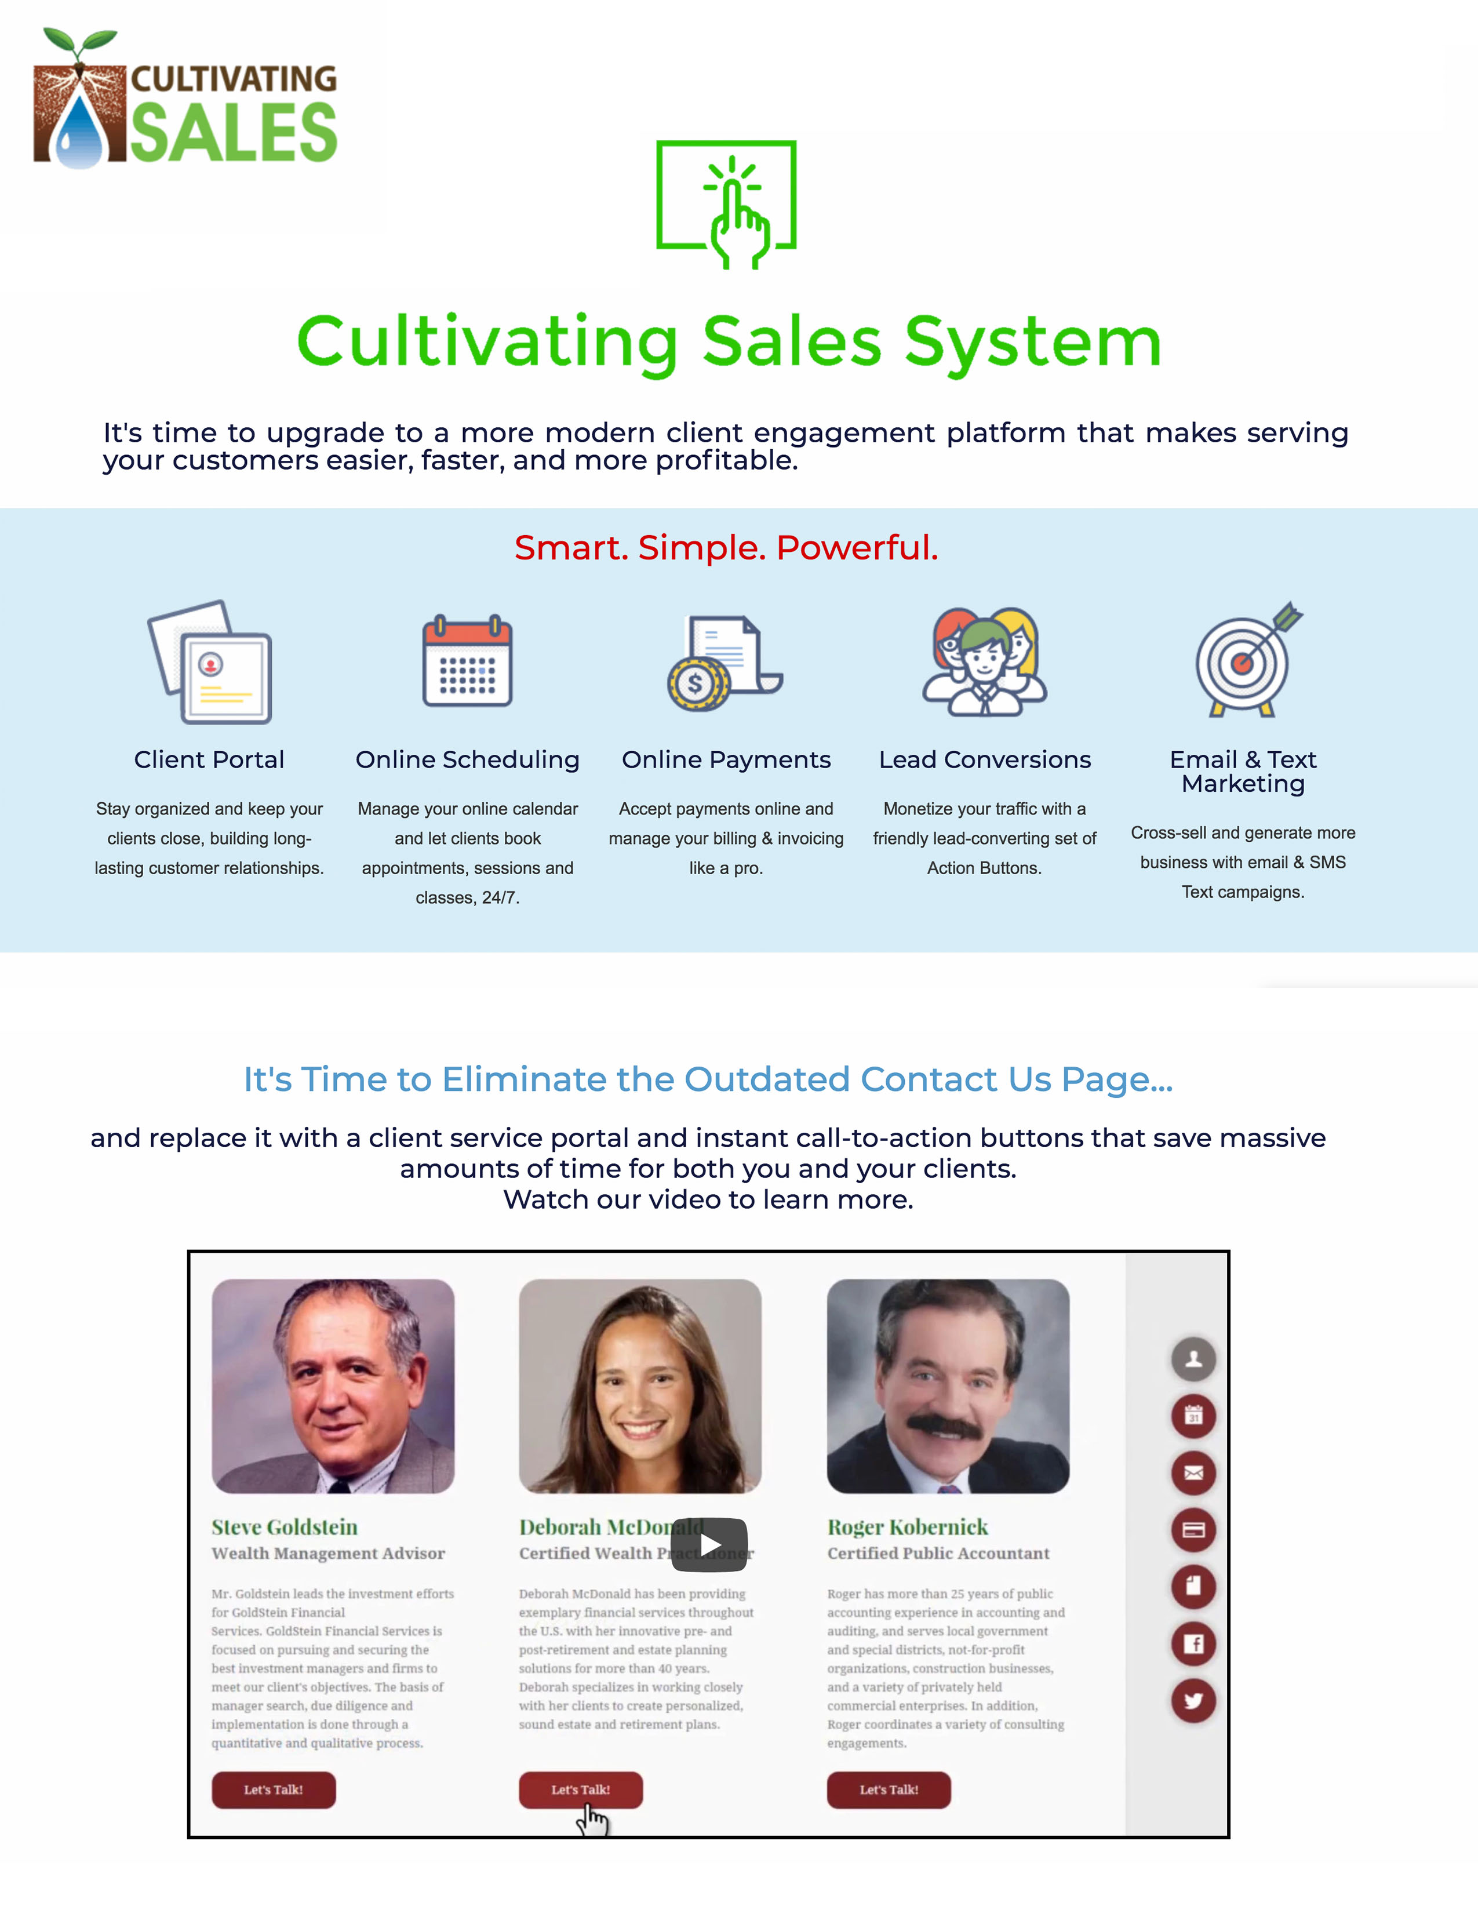

* + This layout is more effective in that it introduces the message straight away, "It's time to upgrade to a more modern client engagement platform that makes serving your customers easier, faster, and more profitable." The website then goes into the details of the service that it provides with "Client Portal, Online Scheduling, Online Payments, Lead Conversions, Email & Target Marketing." The video following this content is like a "Learn More" action once they are already hooked on what it is you offer.
  + Suggestion 2: Go through a website hosting service like WordPress or Wix

· **Email Newsletter**

* + Partnering with “Expressary” and/or using MailChimp.
    - Always be adding and maintaining emails into your own CRM system and maintaining the clientele that you already have. Maintaining potential customers is very important too.

·  **Hire an employee**

* + To have a full time employee at $12/hour it would cost you $1,920 a month. Cultivating Sales would need to have at least 20 loyal clients to keep this type of employee on. 20 loyal clients paying at the premium level will give you the net income before taxes of: $2,580 a month. This is just a goal of profit that can be kept in mind.

· **Cutting down the length** of potential customers utilizing the free trial that are not taking an action of purchasing any plan

· **Pushing** the premium plan to the customers

* + This can be done through the email newsletters, infographic videos, content posts, social media, or blogging. There are many platforms that you could possibly do to implement this into your strategy.

## IX. Tactics/Actions

Cultivating Sales has yet to focus intently on getting out in the digital marketing realm. Cultivating Sales, being new to the market place, is in dire need of content to give to its potential clientele. Digital marketing consists of social media, content marketing, Google ads, banner ads, and video marketing (Mercer). Though cultivating sales has a twitter, LinkedIn, Facebook, and a YouTube account, it does not keep up or maintain content on these channels. Cultivating Sales has been focused on cold-calling and networking events, which is great to keep on doing, but in order to reach and engage it's customers it will need to be active digitally.

We have only so much time in a day, so it is important to look at the big picture for the future a business could have in many different areas than restricting to the hometown of Cultivating Sales, especially when it is a business that is ran all online. Keeping your clientele close to you by location is great, but with a business like Cultivating Sales why not try everywhere else too? There are so many solo-entrepreneur businesses all over the United States that could benefit from what you offer. Restricting Cultivating Sales to locals by only doing traditional marketing may not be the most effective strategy to be implementing in the long run always. The traditional marketing being the initial strategy has put your best foot forward, but now it’s time to work on expanding your scope. Digital marketing will be the answer to expanding your scope outside of Wisconsin.

Maintaining a client list that is loyal and will forever use the CRM is the main goal. Keeping loyal customers maintains the cash flow. It is best to have loyal customers than it is to sign on a new customer, so implementing the email newsletter, and updating content is an action Cultivating Sales must take first to maintain the 10 clients interest that have already purchased the CRM system (Myler). The more personal and authentic a relationship is with any customer that Cultivating Sales attains, then the more irreplaceable Cultivating Sales will become to that customer.

**Action Plan** 1

|  |  |  |  |
| --- | --- | --- | --- |
| Strategy | Who | Due Date | Cost |
| Social Media Management | Melissa | Daily | Hootsuite Costs: $29 a month for a professional plan (https://hootsuite.com/plans/business) |
| Part-Time Employee (Intern) | Melissa | A year from now | $12/hour - $960 a month |
| Content Creation  (Podcasts, Videos, Ads, Email Newsletter) | Melissa | 1 a week | $0 |
| Search Engine Optimization | Melissa | As soon as possible | $0 |
| AdWords | Melissa | As soon as possible | $129 a month |
| Website | Melissa | As soon as possible | Suggestion 1: $0  Suggestion 2: Unknown |

X. Controls

A standard that Cultivating Sales can measure to see the effectiveness of the marketing strategy is noticing an increase in clientele and inquiries. If you are getting at least 5 inquiries a week, then you can be sure that the marketing strategy is as effective as we’d hope. These inquiries are leading to brand awareness. With these inquiries, you must catch information like emails to keep these potential customers close. If you are getting at least 1 loyal customer using a premium plan at $129 a month from what you think is a Google AdWords advertisement, or other PPC advertising, then you are already paying off the AdWords if you set your monthly budget at $129 a month (the cost a customer of Cultivating Sales pays for a premium plan). If you are receiving 2 loyal customers from PPC advertising, then you are noticing a return on your investment from AdWords. To measure this return on investment in AdWords - capture data to on Google analytics on what day customers inquire, then notice if that day was a Google AdWords conversion.

**XI. Resources and Budget**

* Achieving 200 clients by next February requires signing up 18 new customers per month. Estimating that ¾ of the new clients will get the original $79 Cultivating Sales membership and ¼ will get the Platinum membership (Following Internal Trend Chart 1). This goal will raise $17,376 dollars and earn a total profit of $11,120.
* With the profit achieved the business can hire on a part time or full-time employee. Having a sales associate dedicate 5 hours Monday-Friday will cost $300 a week. A full-time employee would cost $480 a month.
* Marketing and organizational tools that you can utilized include: a Social Media Calendar, Podcasts, and Google Analytics.
* 3rd party vendors that can increase web impressions and track website progress includes: Mail Chimp and Paying for Google Ads. Mail Chimp will allow you to see your email recipient's activity as they navigate your website. This will give you good idea of who is a hot lead and where they’re interests lie. This service costs $10 a month or a trial version is available. Dedicating a chunk of money to create sponsored ads on multiple platforms might reach a cold market that is currently unreached. A $1500 budget will allow the business to run $129 worth of ads a month. The risk is high with this strategy, but it could yield surprising results.
* Attending farmers markets or possibly paying for a booth for the summer months will allow you to get your name to the public and network with different types of businesses. Estimating that it costs $150-$200 to purchase a lot at a single farmers market. $1000 dollars can be dedicated to attending 5-6 farmers markets throughout Wisconsin will generate leads and may give better insight on how to market the product on a larger and visual scale.
  + Assuming that the cash flow is available, and you apply all of these methods it will cost $5,910. Leaving $5,290 of pure profit that can be reinvested or used as a payday.

**Conclusion**

As a new company Cultivating Sales has a lot of options in which direction they want to go as a company. With that being said, no matter what direction is chosen there will need to be more customers. We believe that the best way to do this is through the marketing techniques that we’ve highlighted above. These include social media calendars, which would allow you to get the most use out of various social media platforms. Podcasts are an excellent way to network. SEO increases the odds of someone finding your business. Videos will help clients and potential customers better understand your business. PPC Advertising, which will put your product in front of your demographics. Fixing the website will make your business look more professional. Email Newsletters will keep potential customers thinking about cultivating sales. Hiring an employee can result in more time to focus on the most important task- free trial to premium plan retention strategies, which will get clients on the paid plan. All in all, we believe that Cultivating Sales is a great business and will continue to grow.

Appendix A

CRM Market Revenue and CRM Market Share

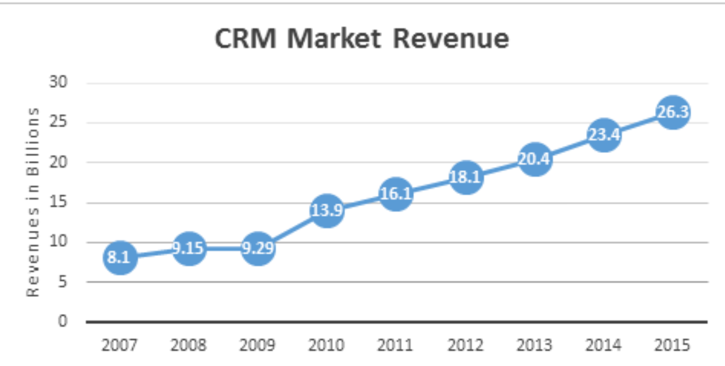

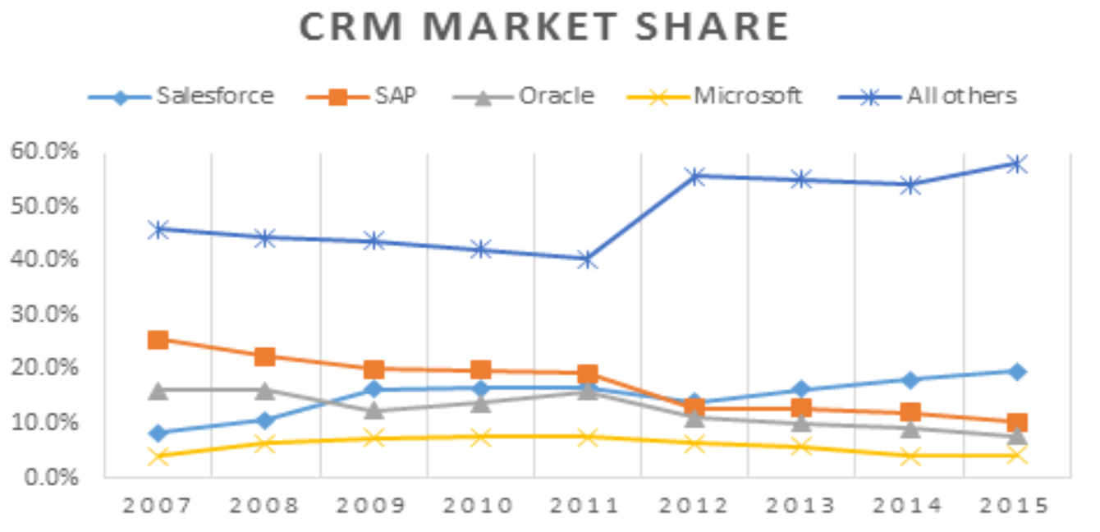

References

“Digital Display Ads.” *SmartSearch*, smartsearch.info/digital-display-ads/.

HubSpot. “Marketing.” *HubSpot Blogs*, blog.hubspot.com/marketing.

“Make Infographic Videos for Free.” *Animaker*, [www.animaker.com/infographics](http://www.animaker.com/infographics).

Mercer, Chris. “Traditional Vs. Online Marketing.” *Seriously Simple Marketing*, 2017, seriouslysimplemarketing.com/.

Myler, Larry. “Acquiring New Customers Is Important, But Retaining Them Accelerates Profitable Growth.” *Forbes*, Forbes Magazine, 8 June 2016, www.forbes.com/sites/larrymyler/2016/06/08/acquiring-new-customers-is-important-but-retaining-them-accelerates-profitable-growth/.

Tables

Table 1

[Action Plan]

|  |  |  |  |  |
| --- | --- | --- | --- | --- |
| Strategy | Who | Due Date | Cost |  |
| **Social Media Management** | Melissa | Daily | Hootsuite Costs: $29 a month for a professional plan (https://hootsuite.com/plans/business) |  |
| **Part-Time Employee (Intern)** | Melissa | A year from now | $12/hour - $960 a month |  |
| **Content Creation**  **(Podcasts, Videos, Ads, Email Newsletter)** | Melissa | 1 a week | $0 |  |
| **Search Engine Optimization** | Melissa | As soon as possible | $0 |  |
| **AdWords** | Melissa | As soon as possible | $129 a month |  |
| **Website** | Melissa | As soon as possible | Suggestion 1: $0  Suggestion 2: Unknown |  |

Note: [ This Action Plan table exhibits the actionable plan that Cultivating Sales could implement to improve their current marketing situation]

Figures









Figure 1. Cost, sales, gross profit, mark up, gross margin, and commission with the services provided.

Figure 2. Final Gross profit.

Figure 3. Search ad example.

Figure 4. Digital display ad example.

*Figure 5.* Possible website configuration